**Rezolvarea laboratoarelor**

**Grupa 232 – 1**

**SGBD , 2023 – 2024**

**Forma răspunsurilor**

Nume student – Nr exercițiu

Rezolvare

**Laborator 2**

--4

select category, count(distinct title), count(*), count(r.copy_id)

from rental r, title t

where r.title_id = t.title_id

group by category

having count(*) = (select max(count(*))

from rental r, title t

where r.title_id = t.title_id

group by category);

--- Tîrîlă Patric-Gabriel – problema 4

select t2.cat, t2.cnt

from (

select t.category cat, count(*) cnt

from title t

where t.title_id in (

select r.title_id

from rental r

)

group by t.category

) t2

where t2.cnt = (select max(count(*))

from title t

where t.title_id in (

select r.title_id

from rental r

)

group by t.category

)

--Gavrila Alexandru problema 4

select t.category, count(distinct title),count(*), count(r.copy_id)

from title t, rental r

where t.title_id = r.title_id

group by t.category

having count(*) =

(select max(count(*))

from rental r, title t

where r.title_id = t.title_id

group by category);

--Codarcea Alexandru problema 4

select t.category, count(distinct t.title_id)

FROM title t

JOIN rental r ON t.title_id = r.title_id

group by category

having count(*) = (select max(count(*))

FROM title t

JOIN rental r ON t.title_id = r.title_id

group by category);

Ilie Florin-Alexandu -problema 5

select t.title, count(tc.copy_id) as ex_disp

from title t

join title_copy tc on t.title_id = tc.title_id

where tc.status like 'AVAILABLE'

group by t.title;

Liviu Firca problema 5

select title_id,count(title_id)

from title_copy

where lower(status)='available'

group by title_id;

Tîrîlă Patric-Gabriel – problema 5

select t.title, tc2.cnt

from title t, (

select tc.title_id t_id, count(*) cnt

from (select tc3.title_id title_id, tc3.copy_id copy_id, tc3.status status

from title_copy tc3

where tc3.status = 'AVAILABLE'

) tc

group by tc.title_id

) tc2

where t.title_id = t_id;

--5 Caraulasu Catalin

select t.title,count(tc.title_id)

from title_copy tc, title t

where upper(status)='AVAILABLE' and tc.title_id=t.title_id

group by title;

--Codarcea Alexandru problema 5

select t1.title_id, count(t1.title_id)

FROM title t1

JOIN title_copy t2 ON t1.title_id = t2.title_id

WHERE upper(status) = 'AVAILABLE'

group by t1.title_id;

--Gavrila Alexandru problema 5

select title, count(copy_id)

from title t, title_copy tc

where t.title_id = tc.title_id

and upper(tc.status) = 'AVAILABLE'

group by title;

--Dumitrescul Eduard, problema 5

select count(*), t.title

from title_copy tc, title t

where tc.title_id = t.title_id

and upper(tc.status) = 'AVAILABLE'

group by t.title;

--5 DOGARU MIHAIL DANUT

select t.title ,count(tc.copy_id)

from title t,title_copy tc

where t.title_id = tc.title_id

and upper(tc.status) = 'AVAILABLE'

group by t.title;

--5 Papusoi Rares

select count(*), t.title

from title t, title_copy c

where t.title_id = c.title_id

and lower(c.status) like 'available'

group by t.title;

Firca Liviu problema 6

select t.title,c.copy_id,c.status,decode(r.act_ret_date,null,'Not available','available') Status_corect

from title t

join title_copy c on c.title_id=t.title_id

join rental r on (r.copy_id=c.copy_id and r.title_id=c.title_id)

where book_date=(select max(book_date)

from rental

where copy_id=r.copy_id

and t.title_id=title_id);

Tîrîlă Patric-Gabriel – problema 6

select tc.title_id, tc.status, tc.copy_id,

CASE

WHEN r.act_ret_date is null THEN 'RENTED'

WHEN r.act_ret_date is not null THEN 'AVAILABLE'

ELSE 'AVAILABLE'

END

from title_copy tc, rental r

where r.title_id = tc.title_id and r.book_date = (

select max(rr.book_date)

from rental rr

where rr.title_id = tc.title_id and rr.copy_id = tc.copy_id

);

Gavrila Florin-Alexandru – problema 6

select tc.copy_id, tc.status, nvl2(r.act_ret_date, 'AVAILABLE', 'RENTED')

from title_copy tc, rental r

where r.title_id = tc.title_id

and book_date = (select max(book_date)

from rental

where copy_id = tc.copy_id

and tc.title_id = title_id);

Dumitrescul Eduard – problema 6

select t.title_id, t.title, tc.copy_id, tc.status, case

when (tc.copy_id, t.title_id) in

(select r.copy_id, r.title_id

from rental r

join title_copy tc on tc.title_id = r.title_id and tc.copy_id = r.copy_id

where r.book_date = (select max(r2.book_date)

from rental r2

where r2.title_id = r.title_id

and r2.copy_id = r.copy_id)

and r.act_ret_date is null)

then 'RENTED'

else 'AVAILABLE'

end

from title t, title_copy tc

where t.title_id = tc.title_id;

--PROFA

Select a.title_id, title, copy_id, status status_setat,

case when (a.title_id, copy_id) not in (select title_id, copy_id

From rental

Where act_ret_date is null)

then 'AVAILABLE'

else 'RENTED'

end status_corect

From title_copy a, title b

Where a.title_id = b.title_id

order by 1,2;

-- Gavrila Florin-Alexandru problema 7a

select count(*)

from (select tc.title_id, tc.copy_id, tc.status, nvl2(r.act_ret_date, 'AVAILABLE', 'RENTED')

from title_copy tc, rental r

where r.title_id = tc.title_id

and tc.status != nvl2(r.act_ret_date, 'AVAILABLE', 'RENTED')

and book_date = (select max(book_date)

from rental

where copy_id = tc.copy_id

and tc.title_id = title_id));

Dumitrescul Eduard – problema 7a

select count(*)

from (select t.title_id, t.title, tc.copy_id, tc.status status_setat, case

when (tc.copy_id, t.title_id) in

(select r.copy_id, r.title_id

from rental r

join title_copy tc on tc.title_id = r.title_id and tc.copy_id = r.copy_id

where r.book_date = (select max(r2.book_date)

from rental r2

where r2.title_id = r.title_id

and r2.copy_id = r.copy_id)

and r.act_ret_date is null)

then 'RENTED'

else 'AVAILABLE'

end status_corect

from title t, title_copy tc

where t.title_id = tc.title_id)

where status_setat != status_corect;

Tîrîlă Patric-Gabriel – problema 7a

select count(*)

from (

select tc.title_id, tc.status status_1, tc.copy_id,

CASE

WHEN r.act_ret_date is null THEN 'RENTED'

WHEN r.act_ret_date is not null THEN 'AVAILABLE'

ELSE 'AVAILABLE'

END status_2

from title_copy tc, rental r

where r.title_id = tc.title_id and r.book_date = (

select max(rr.book_date)

from rental rr

where rr.title_id = tc.title_id and rr.copy_id = tc.copy_id

)

) tabel

where tabel.status_1 <> tabel.status_2;

--7a DOGARU MIHAIL DANUT (partea din with e de la PROFA)

with tabela as(

Select a.title_id,status status_setat,

case when (a.title_id, copy_id) not in (select title_id, copy_id

From rental

Where act_ret_date is null)

then 'AVAILABLE'

else 'RENTED'

end status_corect

From title_copy a, title b

Where a.title_id = b.title_id

order by 1,2)

select count(t.title_id)

from tabela t

where t.status_setat != t.status_corect;

--Gavrila Florin-Alexandru problema 7b

update title_copy_gfa

set status =

case when (title_id, copy_id) not in (select title_id, copy_id

From rental

Where act_ret_date is null)

then 'AVAILABLE'

else 'RENTED'

end ;

--Dumitrescul Eduard – problema 7b

update title_copy_dev tcd

set status = (

with aux as (select t.title_id title_id, t.title, tc.copy_id copy_id, tc.status status_setat, case

when (tc.copy_id, t.title_id) in

(select r.copy_id, r.title_id

from rental r

join title_copy tc on tc.title_id = r.title_id and tc.copy_id = r.copy_id

where r.book_date = (select max(r2.book_date)

from rental r2

where r2.title_id = r.title_id

and r2.copy_id = r.copy_id)

and r.act_ret_date is null)

then 'RENTED'

else 'AVAILABLE'

end status_corect

from title t, title_copy tc

where t.title_id = tc.title_id)

select aux.status_corect

from aux

where aux.title_id = tcd.title_id

and aux.copy_id = tcd.copy_id

)

Ilie Florin-Alexandru – problema 9

select m.last_name, m.first_name, t.title, count(r.book_date) as NrImp

from member m

join rental r on m.member_id = r.member_id

join title t on r.title_id = t.title_id

group by m.last_name, m.first_name, t.title;

Ilie Florin-Alexandru-problema 10

select m.last_name, m.first_name, t.title, tc.copy_id, count(r.book_date)

from member m

join rental r on m.member_id = r.member_id

join title t on r.title_id = t.title_id

join title_copy tc on r.title_id = tc.title_id

group by m.last_name, m.first_name, t.title, tc.copy_id;

Tîrîlă Patric-Gabriel

CREATE TABLE title_copy_tpg AS SELECT * FROM title_copy;

update title_copy_tpg set status =

CASE

WHEN (title_id, copy_id) in (

select title_id, copy_id

from rental rr

where rr.act_ret_date is null

) THEN 'RENTED'

ELSE 'AVAILABLE'

END;

--Dumitrescul Eduard – problema 8

select rsv.res_date, rsv.title_id, case

when rsv.res_date in

(select rnt.book_date from rental rnt where rnt.title_id = rsv.title_id and rnt.member_id = rsv.member_id)

then 'yes'

else 'no'

end

from reservation rsv;

-- Gavrila Florin-Alexandru problema 8

select CASE when re.res_date in (select r1.book_date

from rental r1

where r1.member_id = r.member_id

and r1.title_id = r.title_id) then 'Da' else 'Nu' end luat_rezervare

from reservation re, member m, rental r

where re.member_id = m.member_id

and m.member_id = r.member_id

and re.title_id = r.title_id;

-- Gavrila Florin-Alexandru problema 9

select m.last_name, m.first_name, t.title_id, t.title, count(*)

from member m, rental r, title t

where r.member_id = m.member_id

and r.title_id = t.title_id

group by m.last_name, m.first_name, t.title_id, t.title

order by 1;

-- Dumitrescul Eduard – problema 9

select m.last_name, m.first_name, t.title_id,

(select count(*)

from rental r

where r.member_id = m.member_id and r.title_id = t.title_id) NR

from member m, title t

order by m.last_name, m.first_name;

-- Dumitrescul Eduard – problema 10

select m.last_name, m.first_name, tc.title_id, tc.copy_id,

(select count(*)

from rental r

where r.member_id = m.member_id and r.title_id = tc.title_id and r.copy_id = tc.copy_id) NR

from member m, title_copy tc

order by m.last_name, m.first_name;

-- Gavrila Florin-Alexandru problema 10

select m.last_name, m.first_name, t.title_id, tc.copy_id, t.title, count(*)

from member m, rental r, title t, title_copy tc

where r.member_id = m.member_id

and r.title_id = t.title_id

and tc.title_id = t.title_id

and tc.copy_id = r.copy_id

group by m.last_name, m.first_name, t.title_id, tc.copy_id, t.title

order by 1;

--Gavrila Florin-Alexandru problema 11

SELECT r.title_id, r.copy_id, tc.status, COUNT(*) AS rental_count

FROM title_copy tc, rental r

where r.title_id = tc.title_id

and r.copy_id = tc.copy_id

GROUP BY r.title_id, r.copy_id, tc.status

HAVING COUNT(*) = (

SELECT MAX(rental_count)

FROM (

SELECT r1.title_id, r1.copy_id, COUNT(*) AS rental_count

FROM title_copy tc1

JOIN rental r1 ON tc1.title_id = r1.title_id AND tc1.copy_id = r1.copy_id

GROUP BY r1.title_id, r1.copy_id

) subquery

WHERE subquery.title_id = r.title_id

);

-- Dumitrescul Eduard-Valentin – problema 11

select tc.title_id, tc.copy_id, (select count(*) from rental r where r.title_id = tc.title_id and r.copy_id = tc.copy_id) no_rented, tc.status

from title_copy tc

where (tc.title_id, ((select count(*) from rental r where r.title_id = tc.title_id and r.copy_id = tc.copy_id)))

in (select tc.title_id ,

max((select count(*) from rental r where r.title_id = tc.title_id and r.copy_id = tc.copy_id))

from title_copy tc

group by tc.title_id);

-- Gavrila Florin-Alexandru problema 12

select count(*)

from rental

where to_char(book_date, 'dd') = '01'

or to_char(book_date, 'dd') = '02';

select count(*)

from rental

where to_char(book_date, 'mm') = to_char(sysdate, 'mm');

-- Dumitrescul Eduard – problema 12 (a, b, c)

with days as (select to_date(trunc(sysdate, 'mm'),'dd.mm.yy')+level-1 day_date

from dual

connect by level <= 2)

select d.day_date,

(select count(*) from rental r where to_char(r.book_date, 'dd-mm-yyyy') = to_char(d.day_date, 'dd-mm-yyyy')) cnt

from days d;

select r.book_date, count(*) no_rented

from rental r

where r.book_date >= to_date(to_char(sysdate, 'mm-yyyy'), 'mm-yyyy')

group by r.book_date;

with days as (select to_date(trunc(sysdate, 'mm'),'dd.mm.yy')+level-1 day_date

from dual

connect by level <= TO_CHAR(LAST_DAY(sysdate),'DD'))

select to_char(d.day_date, 'dd-mm-yyyy'),

(select count(*) from rental r where to_char(r.book_date, 'dd-mm-yyyy') like to_char(d.day_date, 'dd-mm-yyyy')) cnt

from days d;

**Laborator 3**

--9.

select m.member_id, first_name, last_name,

t.title_id, t.title, count(r.title_id)

from member m, title t, rental r

where t.title_id = r.title_id (+)

and m.member_id(+) = r.member_id

group by m.member_id, first_name, last_name, t.title_id, title

order by 1,4;

--11

with info as

(select t.title_id, max(title), c.copy_id, max(status), count(*) nr

from title t, title_copy c, rental r

where t.title_id = c.title_id

and c.copy_id = r.copy_id

and c.title_id = r.title_id

group by t.title_id, c.copy_id)

select *

from info i

where nr = (select max(nr)

from info

where title_id = i. title_id)

order by 1;

-- 12 – dumitrescul eduard

with days as (select to_date(trunc(sysdate, 'mm'),'dd.mm.yy')+level-1 day_date

from dual

connect by level <= TO_CHAR(LAST_DAY(sysdate),'DD'))

select to_char(d.day_date, 'dd-mm-yyyy'),

(select count(*) from rental r where to_char(r.book_date, 'dd-mm-yyyy') like to_char(d.day_date, 'dd-mm-yyyy')) cnt

from days d;

--4.

DECLARE

v_dep departments.department_name%TYPE;

BEGIN

SELECT department_name

INTO v_dep

FROM employees e, departments d

WHERE e.department_id=d.department_id

GROUP BY department_name

HAVING COUNT(*) <> (SELECT MAX(COUNT(*))

FROM emp0_prof

GROUP BY department_id);

DBMS_OUTPUT.PUT_LINE('Departamentul '|| v_dep);

exception

when too_many_rows then

DBMS_OUTPUT.PUT_LINE('mai multe linii!');

when no_data_found then

DBMS_OUTPUT.PUT_LINE('nicio linie!');

END;

/

Exercitiul 6 Liviu

VARIABLE rezultat VARCHAR2(35)

declare

numar number;

BEGIN

SELECT department_name,count(*)

INTO

:rezultat,numar

FROM

employees e, departments d

WHERE e.department_id=d.department_id

GROUP BY department_name

HAVING COUNT(*) = (SELECT MAX(COUNT(*))

FROM

employees

GROUP BY department_id);

DBMS_OUTPUT.PUT_LINE('Departamentul '|| :rezultat||' numarul '|| numar );

END;

/

PRINT rezultat

Ex. 6 – Papusoi Rares

VARIABLE rezultat VARCHAR2(35)

VARIABLE rezultat2 VARCHAR2 (35)

BEGIN

SELECT department_name, count(*)

INTO :rezultat, :rezultat2

FROM employees e, departments d

WHERE e.department_id=d.department_id

GROUP BY department_name

HAVING COUNT(*) = (SELECT MAX(COUNT(*))

FROM employees

GROUP BY department_id);

DBMS_OUTPUT.PUT_LINE('Departamentul '|| :rezultat);

DBMS_OUTPUT.PUT_LINE('Angajati: ' || :rezultat2);

END;

/

-- ex 2 Dumitrescul Eduard

with days as

(select to_date('01.10.2023', 'DD.MM.YYYY') + level - 1 day_date from dual

connect by level <= to_char(LAST_DAY(to_date('01.10.2023', 'DD.MM.YYYY')), 'DD'))

select to_char(d.day_date, 'dd-mm-yyyy'),

(select count(*) from rental r where to_char(r.book_date, 'dd-mm-yyyy') like to_char(d.day_date, 'dd-mm-yyyy')) cnt

from days d;

--2 b

Create table octombrie_prof

( id number(5), data date);

Declare

contor number(3) := 0;

Data_aux date := ‘01-OCT-2023';

Begin

Loop

insert into octombrie_prof

values (contor, data_aux+contor);

contor := contor+1;

exit when contor = 31;

End loop;

End;

/

**Laborator 4**

select employee_id

bulk collect into t

from

(select employee_id

from employees

where commission_pct is null

order by salary)

where rownum<=5;

Tîrîlă Patric-Gabriel ex 1

DECLARE

type colectie is table of employees.employee_id%TYPE index by pls_integer;

v_colectie colectie;

BEGIN

select employee_id

bulk collect into v_colectie

from (

select employee_id

from employees

where commission_pct is null

order by salary asc

)

where rownum <= 5;

for i in v_colectie.first .. v_colectie.last loop

update employees

set salary = salary + (5/100 * salary)

where employee_id = v_colectie(i);

end loop;

END;

**Laborator 5 – PLSQL 3**

--e1

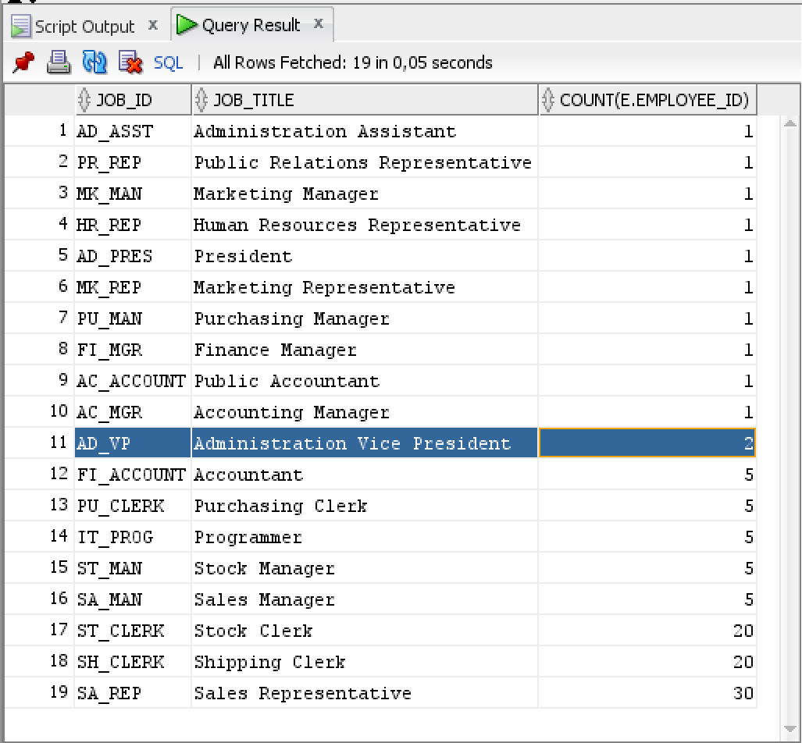

--a. Cursor explicit

DECLARE  
 CURSOR cur_jobs IS  
 SELECT DISTINCT job_id AS job_title FROM employees;  
  
 v_job employees.job_id%TYPE;  
 v_employee_name employees.first_name%TYPE;  
 v_employee_salary employees.salary%TYPE;  
 BEGIN  
 FOR job_rec IN cur_jobs LOOP  
 v_job := job_rec.job_title;  
 DBMS_OUTPUT.PUT_LINE('Job: ' || v_job);  
  
 IF v_job IS NOT NULL THEN  
 FOR emp_rec IN (SELECT first_name, salary FROM employees WHERE job_id = v_job) LOOP  
 v_employee_name := emp_rec.first_name;  
 v_employee_salary := emp_rec.salary;  
 DBMS_OUTPUT.PUT_LINE(' Employee: ' || v_employee_name || ', Salary: ' || v_employee_salary);  
 END LOOP;  
 ELSE  
 DBMS_OUTPUT.PUT_LINE(' No employees found for this job.');  
 END IF;  
 END LOOP;  
 END;  
 /

--profa

DECLARE

CURSOR c1 IS

SELECT job_title, job_id

FROM jobs;

CURSOR c2 IS

SELECT last_name, salary, job_id

FROM employees;

v_titlu jobs.job_title %TYPE;

v1_id jobs.job_id %TYPE;

v_nume employees.last_name %TYPE;

v_salary employees.salary %TYPE;

v2_id employees.job_id %TYPE;

BEGIN

OPEN c1;

LOOP

FETCH c1 into v_titlu, v1_id;

EXIT WHEN c1%NOTFOUND;

DBMS_OUTPUT.put_line('Id-ul jobului : '

|| v1_id

|| ' , '

|| v_titlu);

OPEN c2;

LOOP

FETCH c2 into v_nume, v_salary, v2_id;

EXIT WHEN c2%NOTFOUND;

IF v1_id = v2_id THEN

DBMS_OUTPUT.put_line('Angajatul cu numele '

|| v_nume || ' avand salariul: '

|| v_salary);

END IF;

END LOOP;

close c2;

END LOOP;

close c1;

END;

/

--b. Ciclu cursor

--c. Ciclu cursor cu subcereri

-- Tirila Patric-Gabriel

declare

v_rows_found BOOLEAN := FALSE;

begin

for i in (

select job_title titlu, job_id id

from jobs

) loop

v_rows_found := FALSE;

DBMS_OUTPUT.PUT_LINE('Jobul ' || i.titlu);

for j in (

select last_name lname, salary salary

from employees

where job_id = i.id

) loop

v_rows_found := TRUE;

DBMS_OUTPUT.PUT_LINE('Employee: ' || j.lname || ' ' || j.salary);

end loop;

if v_rows_found = FALSE

then DBMS_OUTPUT.PUT_LINE('Nu are angajati');

end if;

end loop;

end;

/

--d. Expresii cursor